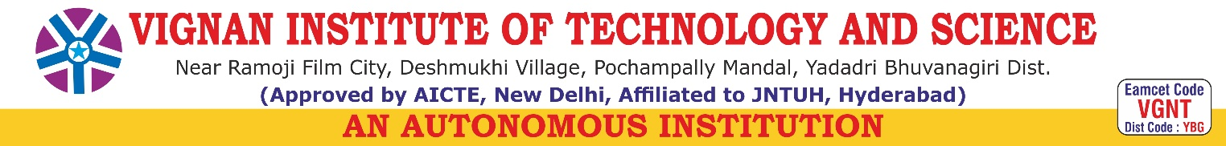
DEPARTMENT OF COMPUTER SCIENCE AND ENGINEERING (DATA SCIENCE)
III YEAR II SEM SECTION-A A.Y 2025-26

INNOVATIVE PROJECT ABSTRACT
TITLE OF THE PROJECT: Food Calorie Prediction Using Machine Learning
Batch No | Roll Number | Name of the Student | Email
CSE-DS-3A-7 | 23891A6741 | MUNAGALA NAVADEEP REDDY | rmnavadeep@gmail.com
 | 23891A6735 | KONTHAM SATHWIK REDDY | sathwikkontham@gmail.com
 | 23891A6748 | PISATHI SRUTHI REDDY | sruthipisati@gmail.com
 | 23891A6702 | ALUGUBELLY ANUSHA REDDY | anushareddy.ar333@gmail.com
Project Guide: Mrs G Madhavee Latha
ABSTRACT
This project, Food Calorie Prediction Using Machine Learning, aims to estimate the calorie content of food items based on their nutritional values such as protein, fat, carbohydrates, fiber, and sugar. Maintaining a balanced diet and tracking calorie intake are important for health and fitness. However, manually calculating calories from nutritional information can be difficult and time-consuming.
In this system, a machine learning model is trained using a food nutrition dataset to learn the relationship between different nutritional components and the total calorie value. The model uses regression techniques, particularly the Random Forest Regressor, to analyze the input nutritional features and predict the approximate calorie content of food items.
The proposed system can be useful for diet monitoring, fitness applications, and health management platforms where users need quick and accurate calorie estimates. From a Software Project Management perspective, the project follows structured development practices including dataset collection, data preprocessing, model training, evaluation, and prediction system implementation.
Overall, this project demonstrates how machine learning can be applied to nutritional data to create an intelligent system that helps users estimate calorie intake efficiently and supports healthier lifestyle choices.

Project Guide IP Coordinator

HOD-CSE (DS)

